Methods Check

Review of Emissions Estimates & Activity Data applied in the RSPB Gola Feasibility Assessment

2024-12-23

## Summary

## Project files reviewed

| **Filename** | **Filepath** |
| --- | --- |
| community forestry zone REDD objectives.docx | ~/20087 - RSPB Gola Feasibility/Working Files/Gola VER estimate/ |
| ER_Workbook_Gola_Liberia.xlsx | ~/20087 - RSPB Gola Feasibility/Working Files/Gola VER estimate/ |
| ERR_assumptions_meeting_notes_final.docx[1] | ~/20087 - RSPB Gola Feasibility/Working Files/Gola VER estimate/ |
| Proxy Baseline Allocation Report.docx | ~/20087 - RSPB Gola Feasibility/Working Files/Gola VER estimate/ |
| VER Notes.docx | ~/20087 - RSPB Gola Feasibility/Working Files/Gola VER estimate/ |
| 10b Gola REDD Baseline Workplan VCS.pdf | ~/20087 - RSPB Gola Feasibility/Working Files/Data from RSPB/OneDrive_1_02-05-2024.zip |
| ProjectArea.shp | ~/20087 - RSPB Gola Feasibility/Working Files/Winrock_GIS Analysis Gola/ |

*Import aoi*

aoi = sf::read_sf("~/OneDrive - Winrock International Institute for Agricultural Development/20087 - RSPB Gola Feasibility/Working Files/Winrock_GIS Analysis Gola/ProjectArea.shp") |> sf::st_transform(3857) # supports mosaicking across multiple UTMs  
aoi = aoi |>  
 sf::st_cast("POLYGON") |>  
 sf::st_cast("MULTIPOLYGON")  
  
bbox_expand = terra::vect(terra::ext(vect(aoi)) * 1.3)  
bbox_frame = terra::vect(terra::ext(vect(aoi)) * 1.1)  
bbox = sf::st_as_sf(bbox_frame)   
terra::crs(bbox_expand) = "epsg:3857"  
terra::crs(bbox_frame) = "epsg:3857"  
sf::st_crs(bbox) = 3857

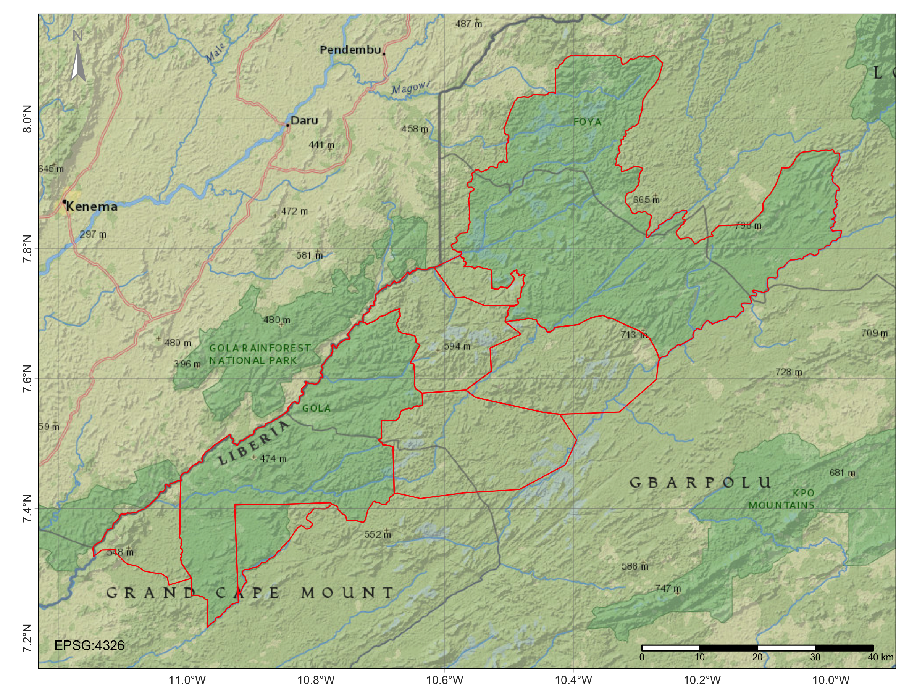

Figure 1: Site map showing proposed extent as defined by ProjectArea.shp

## Area check

In Liberia, the official definition of forest land is provided by the Forestry Development Authority (Liberia 2019), including areas of land that meet the following criteria:

* Canopy cover of minimum 30%;
* Canopy height of minimum 5m or the capacity to reach it;
* Covering a minimum of 1 hectare of land.

aoi$area_m2 = round(as.numeric(st_area(aoi) * 0.0001, 4))  
aoi_select = aoi |>  
 dplyr::select(NAME, DESIG, area_m2) |>  
 dplyr::filter(  
 NAME == "Gola Forest National Park" |   
 NAME == "Tonglay" |  
 NAME == "Normon") |>  
 sf::st_drop_geometry() |>  
 janitor::adorn_totals() |>  
 knitr::kable(font_size = 7) |>  
 kable_styling("striped", full_width = F)  
aoi_select

NAME

DESIG

area_m2

Gola Forest National Park

National Park

90922

Tonglay

Community Forest

30247

Normon

Community Forest

7170

Total

* 128339

# check for artefacts or "forest slivers"  
slivers = aoi |>  
 dplyr::filter(as.numeric(area_m2) < 1)  
slivers # no slivers found

Simple feature collection with 0 features and 30 fields  
Bounding box: xmin: NA ymin: NA xmax: NA ymax: NA  
Projected CRS: WGS 84 / Pseudo-Mercator  
# A tibble: 0 × 31  
# ℹ 31 variables: WDPAID <dbl>, WDPA_PID <chr>, NAME <chr>, ORIG_NAME <chr>,  
# DESIG <chr>, DESIG_TYPE <chr>, IUCN_CAT <chr>, INT_CRIT <chr>,  
# MARINE <chr>, REP_M_AREA <dbl>, GIS_M_AREA <dbl>, REP_AREA <dbl>,  
# GIS_AREA <dbl>, STATUS <chr>, STATUS_YR <dbl>, GOV_TYPE <chr>,  
# MANG_AUTH <chr>, MANG_PLAN <chr>, VERIF <chr>, METADATAID <dbl>,  
# SUB_LOC <chr>, PARENT_ISO <chr>, ISO3 <chr>, Comments <chr>,  
# Landscape <chr>, Shape_Leng <dbl>, Shape_Area <dbl>, Areaha <dbl>, …

Results confirm the dataset is free from forest patches that are smaller than the approved area definition.

## LULC check

*Data processing*

* raster normalization applied cloudless pixel ranking & median back-fill;
* baseline beyond temporal extent of sentinel (**landsat used instead?**);
* training sample extracted from GLanCE dataset[2], which was processed using **class migration** algorithm;
  + Although Verra lacking requirements for class migration (i.e. VT0007, VMD0055, VM0048), we may advise client on best practices and showcase improved accuracy in following comparisons (Verra 2023, 2024, 2021).
  + Level-1 classes in the GLanCE dataset were recoded to match feature labels reported in the “Lookups” sheet of “ER_Workbook_Gola_Liberia.xlsx”. For review, the following table compares GLanCE’s data dictionary and Liberia’s methodological report to present feature classes in their original format and converted format ( “>>” ) (Woodcock et al., n.d.; Liberia 2019).

| RSPB classes |  | GLanCE classes |  |
| --- | --- | --- | --- |
|  |  | Developed (3) | Areas covered with structures, built-up |
| Bareground (0) |  | Barren (4) >> Bareground (0) | Areas of soils, sand, or rocks where <10% is vegetated |
| Regrowth (1) |  | Herbaceous (7) >> Regrowth (1) | Areas of <30% tree, >10% vegetation, but <10% shurb |
| Farmbush (2) |  | Shrublands (6) >> Farmbush (2) | Areas of <30% tree, >10% vegetation, & >10% shrub |
| Forest (3) |  | Tree Cover (5) >> Forest (3) | Areas of tree cover > 30%. |
| Water (4) |  | Water (1) >> Water (4) | Areas covered with water year-round (lakes & streams) |
| Swamp (5) |  | Developed (3) >> Developed (99) | Areas covered with structures, built-up |
| Cocoa (6) |  | Ice/Snow (2) >> Ice/Snow (88) | Areas of snow cover > 50% year-round |
| Oil Palm (7) |  |  |  |

Training samples are fitted to a Random Forest model, a Bayesian smoothing, and evaluated using confusion matrix and probabilistic uncertainty of classification. Subseuqently, new samples were derived in areas of high uncertainty before classifiers were re-evaluated with a second confusion matrix.

# download & filter training dataset  
samples = read.csv("./data/glance_dataset.csv")  
train_data = sits::sits_sample(samples, frac = 0.7)  
test_data = sits::sits_sample(samples, frac = 0.3)  
  
# assemble cube from stac  
cube_2023_aws = sits_cube(  
 source = "AWS",  
 collection = "SENTINEL-2-L2A",  
 roi = aoi,  
 bands = c("B04", "B08", "CLOUD"),  
 start_date = "2023-01-01",  
 end_date = "2023-03-01"  
 )  
  
# normalize cube  
cube_2023_reg = sits_regularize(  
 cube = cube_2023_aws,  
 res = 10,  
 period = "P60D",  
 multicores = 16,  
 output_dir = "./data/cube_2023"  
 )  
  
# Derive NDVI  
cube_202407_spectral <- sits::sits_apply(  
 data = cube_202407_reg,  
 NDVI = (B8A - B04) / (B8A + B04),   
 output_dir = './cubes/2024_reg',  
 memsize = 6,  
 multicores = 4,  
 progress = T  
 )  
  
ndvi = list.files("./cubes/2024_reg",   
 pattern = 'NDVI', full.names = T, all.files = FALSE)|>  
 lapply(terra::rast)|>  
 sprc() |>  
 mosaic()  
terra::mask(ndvi, vect(aoi))  
aoi = sf::st_transform(aoi, crs(ndvi))  
ndvi = terra::crop(ndvi, vect(aoi), mask=T)  
ndvi = ndvi * 0.0001  
  
writeRaster(ndvi, "./cubes/2024_mosaic/NDVI_2024_07.tif", overwrite=T)  
  
  
# train classifier  
rfor_model = sits_train(train_data, sits_rfor())  
  
# classify cube  
cube_2023_prob = sits_classify(  
 data = cube_2023_reg,   
 ml_model = rfor_model,   
 output_dir = "./data/cube_2023"  
 )  
  
# smooth cube (probability segmentation)  
cube_2023_seg = sits_smooth(cube_2023_prob, output_dir = "./data/cube_2023")  
  
# serialize cube  
cube_2023_class = sits_label_classification(bayes_cube, output_dir = "./data/cube_2023")   
  
# mosaic cube  
cube_2023_mosaic = sits_mosaic(  
 cube = cube_2023_class,  
 roi = data_multipolygon,  
 crs = "EPSG:3857",  
 output_dir = "./data/mosaics"  
 )

Accuracy assessments

cube_2023_uncert = sits_uncertainty(  
 cube = cube_2023_class, # may also input cube_2023_prob & cube_2023_seg  
 output_dir = "./data/uncertainty"  
 )  
  
hist(cube_2023_uncert)  
  
cube_2023_acc = sits_accuracy(cube_2023_mosaic, validation = test_data)

Liberia, Government of. 2019. *Liberia’s Forest Reference Emission Level Submission to the UNFCCC*. 1. Forestry Development Authority.

Verra. 2021. *VT0007: Unplanned Deforestation Allocation Tool*. 0.1. Verra. <https://verra.org/wp-content/uploads/2024/02/VT0007-Unplanned-Deforestation-Allocation-v1.0.pdf>.

———. 2023. *VM0048: Reducing Emissions from Deforestation and Forest Degradation*. 1.0. Verra. <https://verra.org/wp-content/uploads/2023/11/VM0048-Reducing-Emissions-from-Deforestation-and-Forest-Degradation-v1.0-1-1.pdf>.

———. 2024. *VMD0055: Estimation of Emission Reductions from Avoiding Unplanned Deforestation*. VCS Module 1.1. Verra. <https://verra.org/wp-content/uploads/2024/10/VMD0055-Estimation-of-Emission-Reductions-from-Avoiding-Unplanned-Deforestation-v1.1-CLEAN-2024.10.21.24.pdf>.

Woodcock, Curtis, Pontus Olofsson, Thomas Loveland, Chris Barber, and Zhe Zhu. n.d. “Global Land Cover Estimation (GLanCE) Product User Guide Version 1.0 August 2022.”

1. “RSPB is concerned that the Verra baselines will be inaccurate because they will use: existing freely available global data like ESA (European Space Agency) landcover and Hansen Global Forest Change to measure forest cover. These overestimate the amount of native forest that exists because these data sources can’t distinguish between native forest and some other habitats such as agroforest in the Greater Gola Landscape (GGL), despite doing so effectively elsewhere (Brittany has verified this in the GGL). This is because the GGL is fine-grained (small patches of rotational swidden agriculture) and agroforestry often has dense canopy cover, which means only satellites collecting very high-resolution images can detect small habitat patches and small gaps in canopy cover. This is important because although the habitats can look similar, the above-ground carbon is far less than that of forest.”
2. For replication, the full unprocessed dataset was stored in personal drive folder here: <https://drive.google.com/file/d/1FhWTpSGFRTodDCY2gSGhssLuP2Plq4ZE/view?usp=drive_link> - To extract from source, java script and google earth engine account needed.